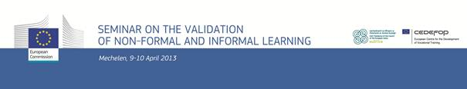

DRAFT Programme
Seminar on validation of non-formal and informal learning
Jointly organised by the European Commission (DG EAC) and Cedefop
in association with the Irish Presidency of the Council of the EU
Mechelen, 9-10 April 2013, Lamot Conference Centre

Day 1

8:30 – 9:00 Welcome and Registration
9:00 – 9:10 Opening statement on the role of validation of non-formal and informal learning for competitiveness, growth and jobs
Jan Truszczynski, Director-General DG Education and Culture, European Commission
9:10 – 9:20 Opening statement on the role of national policies in promoting the validation of non-formal and informal learning on behalf of the Irish Presidency
Andrina Wafer, Manager of Lifelong Learning, Quality and Qualifications Ireland(QQI)
9:20 – 10:00 Introduction to the Council Recommendation and to the European Guidelines on validating non-formal and informal learning
Koen Nomden, Head of Sector "Skills and Qualifications Recognition Tools", DG Education and Culture, European Commission
Jens Bjornavold, Senior Expert, Cedefop
10:00 – 10:15 Introduction to the seminar methodology
10:15 – 10:45 Coffee Break
10:45 – 12:30 Parallel working sessions on
1) access to and use of validation
2) delivering validation
3) standards and methods of validation
4) quality assurance of validation
12:30 – 13:45 Lunch
13:45 – 15:30 Parallel working sessions on the four themes
15:30 – 16:00 Coffee break
16:00 – 17:45 Parallel working sessions on the four themes
19:30 Dinner

Day 2

9:00 – 9:15 Short feedback session and introduction to the second day's programme
9:15 – 11:00 Parallel working sessions on the four themes
11:00 – 11:30 Coffee break
11:30 – 12-30 Plenary discussion on the use of the Guidelines for validating non-formal and informal learning in practice
12:30 – 13:30 Lunch
13:30 – 14:30 Feedback session on the results achieved by the four working groups
14:30 – 15:00 Seminar conclusions and closure
Ana Carla Pereira, Head of Unit "Skills and Qualifications ; Multilingualism policies, DG Education and Culture, European Commission

