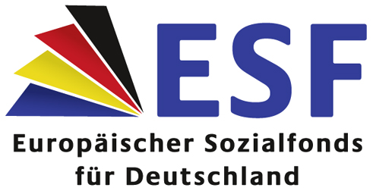
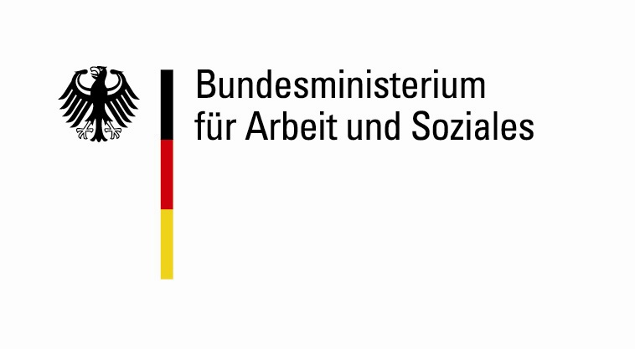

Kick-Off meeting of the Learning Network on Transnational Mobility Measures for Disadvantaged Youth and Young Adults
27-28 February 2013
Ministry of Labour and Social Affairs
Room 1-26 (Wilhelm-Sued)
Wilhelmstrasse 49, 10117 Berlin

Draft Agenda

Wed 27 Feb | Programme
13:00 – 14:00 | Arrival / Refreshment
14:00 - 14:15 | Welcome  Susanne Strehle, Federal Ministry of Labour & Social Affairs Germany  State of play Commission’s grant / budget and concept/ external experts  and general issues
14:15 – 17:15 | Outline work plans for main tasks upcoming in 2013 and discussion  - Develop and agree a timetable (Feb-June 2013)  - Task A - Timetable Overview / Germany  - Draw up and agree on the parameters of a coordinated call (Feb 2013 - mid-2014)  - Task B - Common criteria for Eligibility / Germany  - Task C - Target group / Sweden  - Task D - Quality criteria / Germany and Galicia  - Task E - Efficient Implementation / Italy  - Facilitation of Network, Evaluation, Tools  - Task H - Partner Search Database / Germany  - Task J - Webpage / Germany  - Task N - External Evaluation / Germany  - Task O - Facilitation of the network / Germany
15:30 - 16:00 | Coffee

Thu 28 Feb | Programme
09:30 | Welcome back
09:30 – 12:00 | Overview of tasks starting later - questions and discussion  - Publish a coordinated call based on agreed parameters (mid-2014)  - Task F - Drafting coordinated Call / Germany  - Task G - Support for launching national/regional calls  - Support launch of national/regional calls (mid/end-2014)  - Task I - Partner Search Forum / Poland  - Dissemination of products (mid/end-2014)  - Task K - Midterm conference Berlin / Germany  - Task L - Final conference / France  - Task M - Documentation final results / Germany
11:00 - 11:30 | Coffee break
12:00 - 13:00 | Summary of results - next steps  Agreement on dates for next meetings and conferences  Any other business  Closing  Susanne Strehle, Ministry of Labour & Social Affairs Germany
13:00 – 14:00 | Lunch / Departure

