
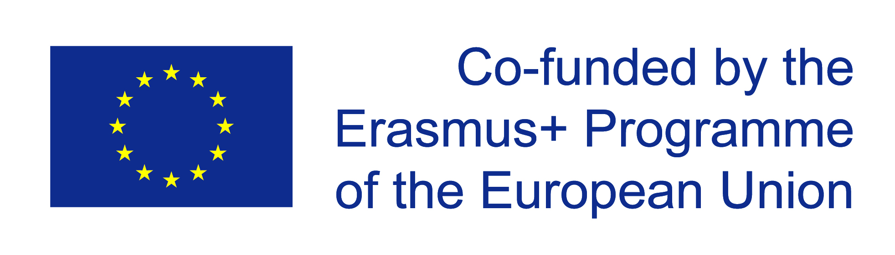

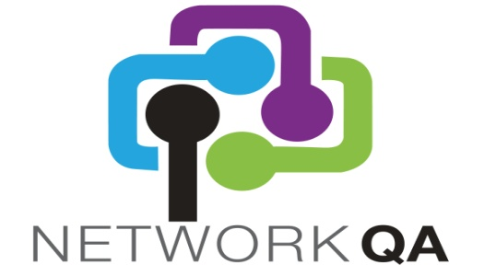

Net-Working for Quality Culture and Assurance (NQCA)

Erasmus+ Programme

2015‐1‐IE01‐KA202‐008657

The impact of Interagency model
on Quality Culture and Quality Assurance
at National, Regional and Local level

CIOFS-FP , Milano

14th October 2016

09.00 Welcome & Opening of Event
Virginia VILLA/Stefania SACCUMAN/Cristina PASQUINI?

09.15 Overview of the NCQA Project & NCQA Model
Julie McCafferty, BJC

09.30 The NQA Quality Label
presentation by Susan Russam, GEMS NI
opening reaction of participants stakeholders

09:45 Toolkit for Policy makers – presentation and debate on possible implementation in Italy
Jasmin Zouzi, MetropolisNet

10.30 Break

10:45 Working session per groups
The impact of the interagency model on QA and QC at local, regional and nation levels
Partners experiences in Belfast, Berlin, Dublin, Heves, London, Turku and Milan

12.50 Conclusions
Facilitator of the working session

12.30 Light Lunch

13.30 Closure of Event

page 55 of the application:

This is a one day event taking place at the end of the 3rd transnational meeting in Rome. The focus is to learn from the host organisation Ciofs-fp about how the interagency model at local, regional and nation levels is impacting on QA and quality culture development. Stakeholders from the interagency groups along with other interested organisations will be invited to attend. It will also provide an opportunity for MetropolisNet to present the Toolkit for Policy makers and to gauge how this could be implemented in an Italian context. Again the importance of partners attending is crucial for the sharing of knowledge and best practice and for disseminating the overall project results to date. The NQA quality label will be presented and stakeholders invited to express their interest with Ciofs-fp.
CIOFS-FP will organise this event which will be held in Rome in month 13 of the project.

40 signatures are required and partner signatures do not count.

