**Persone a rischio povertà – UE28**

**2012 - Donne**

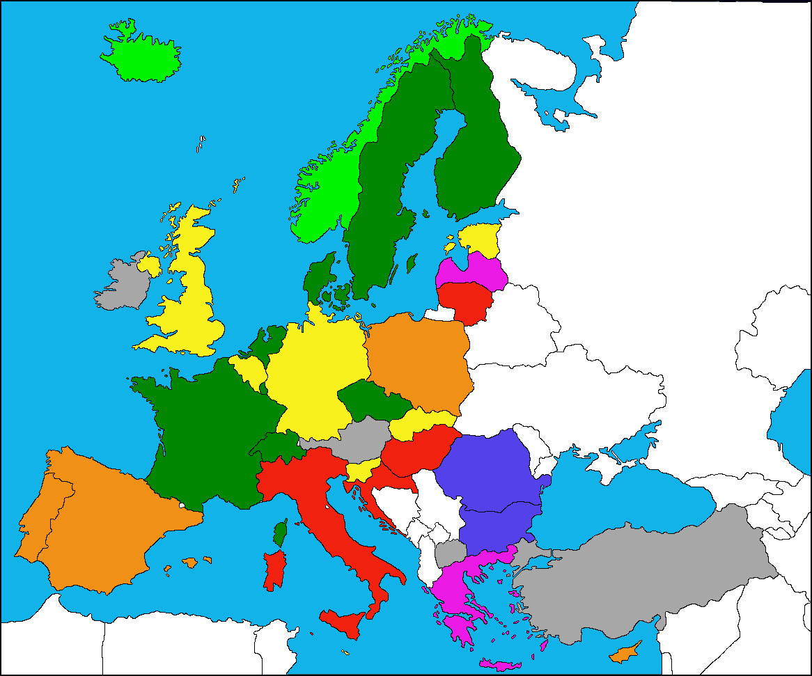

|  |  |
| --- | --- |
|  | <15 % |
|  | 15-20 % |
|  | 20-25 % |
|  | 25-30 % |

|  |  |
| --- | --- |
|  | 30-35 % |
|  | 35-40 % |
|  | >40 % |
|  | Dato non disponibile |