**Neet rates 15-24enni - Totale**

**UE 27 - 2012**

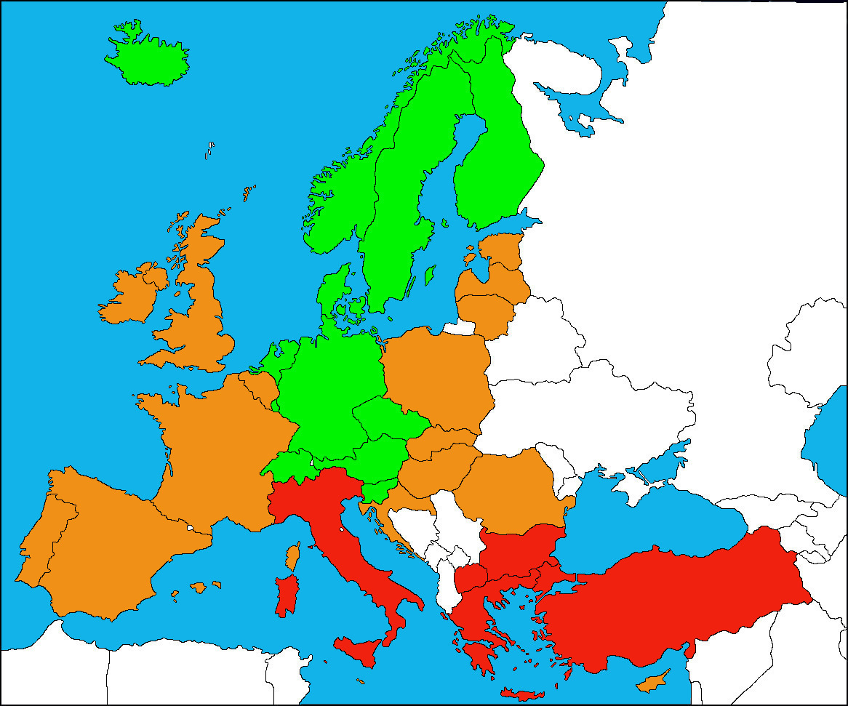

|  |  |
| --- | --- |
|  | < 10 % |
|  | 10-20% |
|  | > 20 % |