**Tasso di occupazione 15-24enni**

**2012 - NUTS 2**

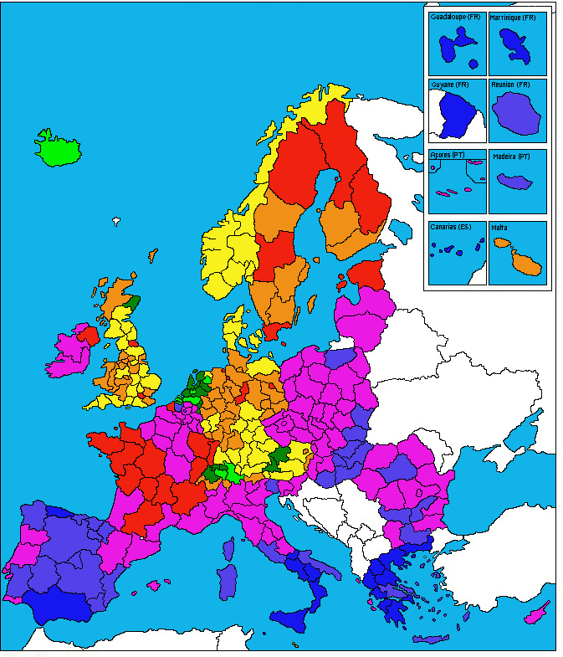

|  |  |
| --- | --- |
|  | >65 % |
|  | 60-65 % |
|  | 50-60 % |
|  | 40-50 % |

|  |  |
| --- | --- |
|  | 30-40 % |
|  | 20-30 % |
|  | 15-20 % |
|  | < 15 % |