**20-24enni con almeno ISCED 3**

**2012 - Totale**

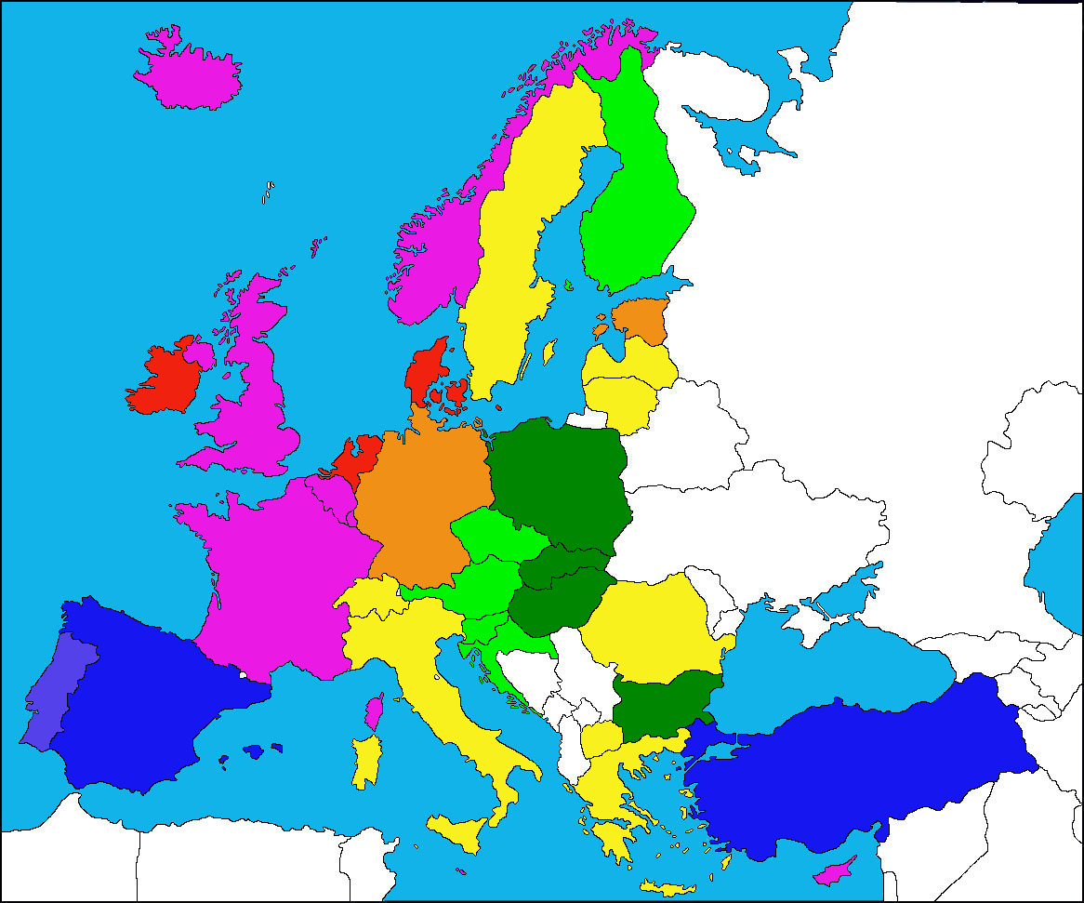

|  |  |
| --- | --- |
|  | >80 % |
|  | 75-80 % |
|  | 70-75 % |
|  | 65-70 % |

|  |  |
| --- | --- |
|  | 60-65 % |
|  | 55-60 % |
|  | 50-55 % |
|  | <50 % |