**25-29enni ISCED 3-4**

**2012 - Totale**

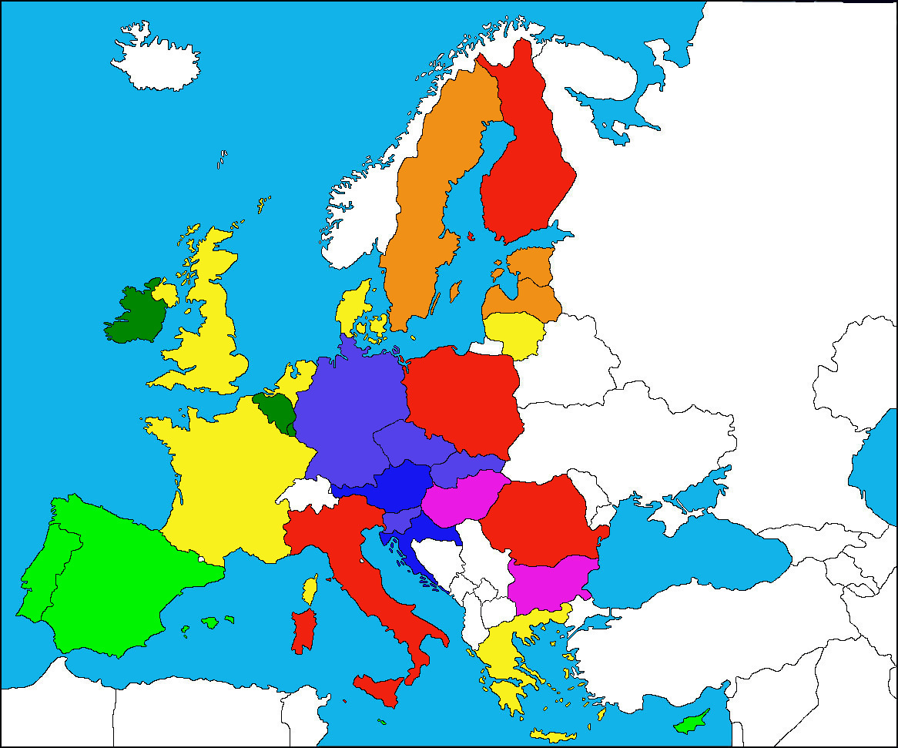

|  |  |
| --- | --- |
|  | <35 % |
|  | 35-40 % |
|  | 40-45 % |
|  | 45-50 % |

|  |  |
| --- | --- |
|  | 50-55 % |
|  | 55-60 % |
|  | 60-65 % |
|  | >65 % |